Marie Kelling
 |  | Paste in your answers for each step below in this column. Paste your actual SQL text, not a screen shot of it. Paste a screen shot of your Result Grid. Be sure to “Snip” your screen shots.
 | Final EER Diagram | 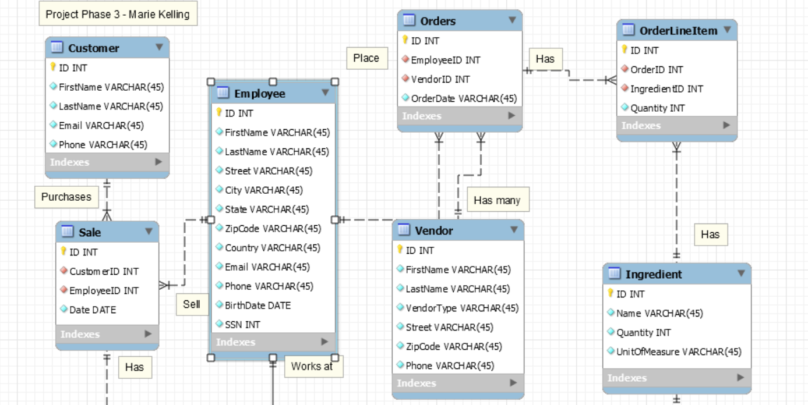  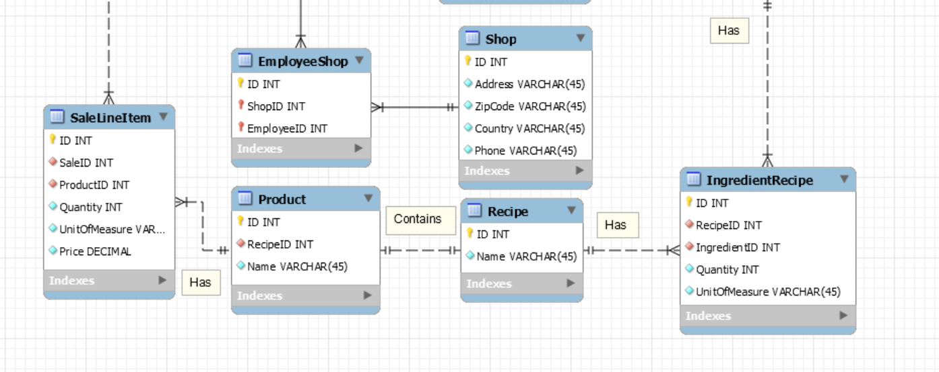
 | Crayon Definitions
  Entity Name | Crayon Definition
  Customer | The Customer table contains records of each customer’s personal information
  Employee | The Employee table keeps track of each employee’s personal information and the shop they’re associated with
  Sale | The Sale table keeps track of the employee who made the sale and the shop the sale was made at
  Shop | The Shop table contains records of each shops location information
  Order | The Order table keeps track of the vendor and the date the order was placed
  Vendor | The Vendor table contains records of each vendor’s location and personal information
  Recipe | The Recipe table keeps track of the recipes used to make the shop’s products
  Product | The Product table contains records of the products sold to customers
  Ingredient | The Ingredient table contains records for the ingredients needed for the shop’s recipes
  Ingredient-Recipe | Implements the many-to-many relationship between Ingredients and Recipes
  Sale-Line-Item | Implements the many-to-many relationship between Sales and Products
  Order-Line-Item | Implements the many-to-many relationship between Orders and Vendors
 | Mockarroo.com screen shot of your Customer table setup | Mockaroo screen shot of your Customer table setup  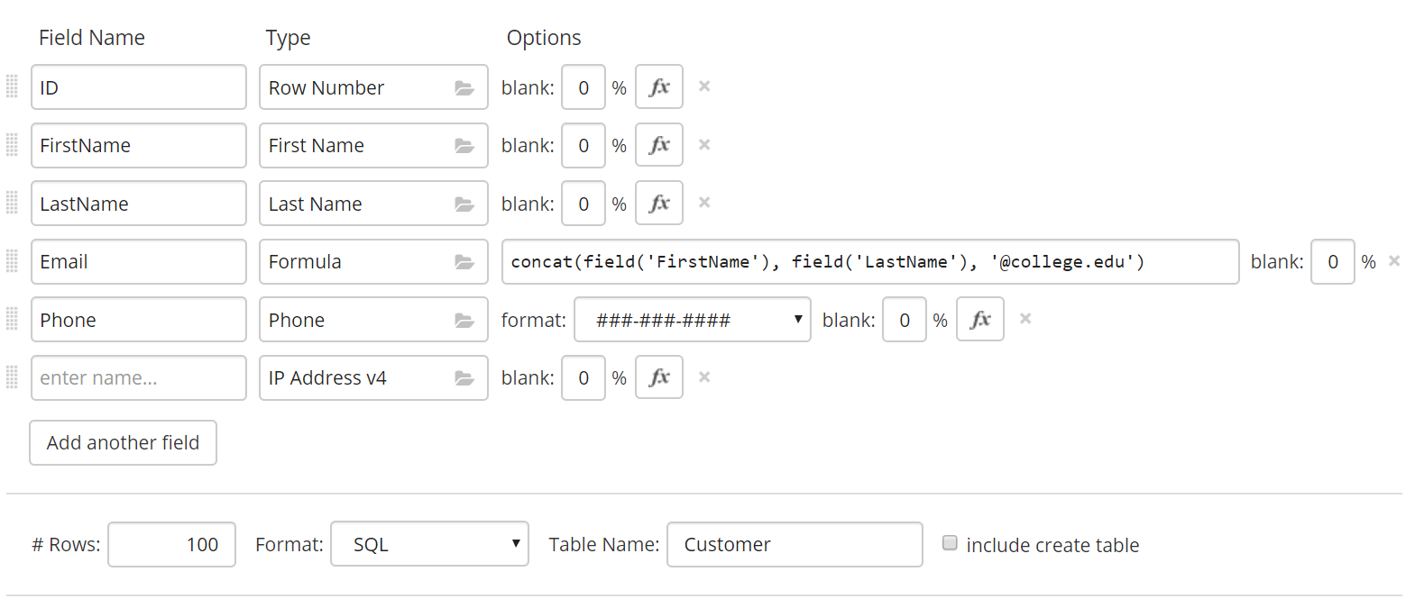
 | SELECT * on each table and up to 10 records from the result grid of each | SELECT * statement and Result Grid from each table
 | Explanation | A WHERE and an ORDER BY clause.  Displays the last name, first name, and ID of all Customers with an ID greater than 5
 | Result Grid | 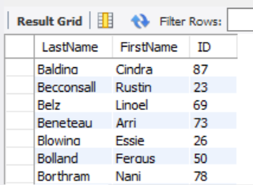
 | SQL | -- Phase 3 Marie Kelling  -- 4. A WHERE clause  USE brendasmek;  SELECT  LastName, FirstName, ID  FROM  Customer  WHERE  ID > 5  ORDER BY LastName;
 | Explanation | An AND or OR in the WHERE clause.  Displays the last name, first name, and ID of all Customers with an ID greater than 5, AND with a first name of ‘Calvin’ or ‘Tito’
 | Result Grid | 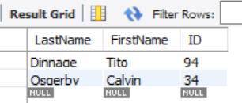
 | SQL | -- Phase 3 Marie Kelling  -- 5. An AND or OR in the WHERE clause  USE brendasmek;  SELECT  LastName, FirstName, ID  FROM  Customer  WHERE  ID > 10 AND FirstName = 'Calvin' OR FirstName = 'Tito'  ORDER BY LastName;
 | Explanation | GROUP BY  Displays the Employees who have made more than 1 sale
 | Result Grid | 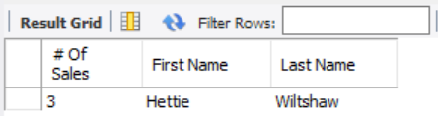
 | SQL | -- Phase 3 Marie Kelling  -- 6. A GROUP BY  USE brendasmek;  SELECT  COUNT(*) AS '# Of Sales',  Employee.FirstName AS 'First Name',  Employee.LastName AS 'Last Name'  FROM  Sale  INNER JOIN  Employee ON Sale.EmployeeID = Employee.ID  GROUP BY Employee.LastName  HAVING COUNT(*) > 1  ORDER BY LastName;
 | Explanation | INNER JOIN  Displays Employees with the Dates and Quantity of the orders they’ve made
 | Result Grid | 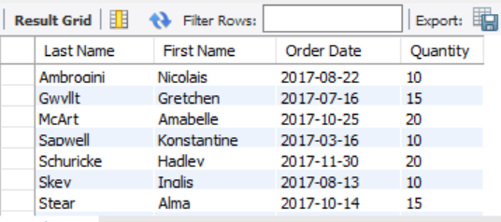
 | SQL | -- Phase 3 Marie Kelling  -- 7. An INNER JOIN of at least 3 tables  USE brendasmek;  SELECT  LastName AS 'Last Name',  FirstName AS 'First Name',  Orders.OrderDate 'Order Date',  OrderLineItem.Quantity AS 'Quantity'  FROM  Employee  INNER JOIN  Orders ON Employee.ID = Orders.EmployeeID  INNER JOIN  OrderLineItem ON Orders.ID = OrderLineItem.OrderID  ORDER BY LastName;
 | Explanation | OUTER JOIN  Displays Employees with their shop ID and Shop location in which they work
 | Result Grid | 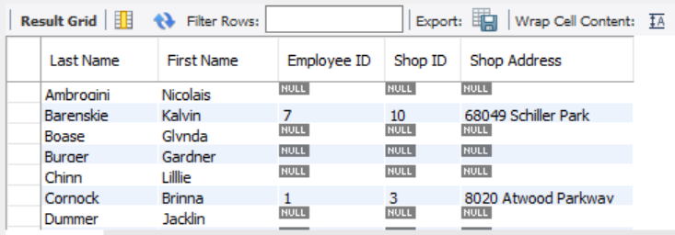
 | SQL | -- Phase 3 Marie Kelling  -- 8. An OUTER JOIN  USE brendasmek;  SELECT  LastName AS 'Last Name',  FirstName AS 'First Name',  EmployeeShop.EmployeeID AS 'Employee ID',  EmployeeShop.ShopID AS 'Shop ID',  Shop.Address AS 'Shop Address'  FROM  Employee  lEFT OUTER JOIN  EmployeeShop ON Employee.ID = EmployeeShop.EmployeeID  LEFT OUTER JOIN  Shop ON EmployeeShop.ShopID = Shop.ID  ORDER BY LastName;
 | Explanation | Roll Your Own query  Displays Employees with the dates of the orders they’ve made, and the vendor type in which the order was placed with.
 | Result Grid | 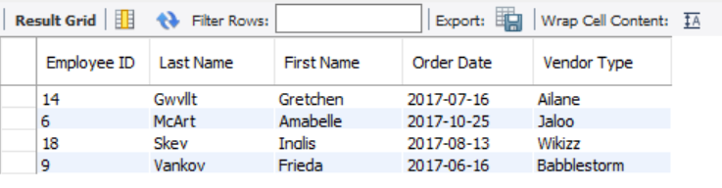
 | SQL | -- Phase 3 Marie Kelling  -- 9. Query of my own design - join at least 4 tables, have a GROUP BY, & have a meaningful purpose  USE brendasmek;  SELECT  Sale.EmployeeID AS 'Employee ID',  Employee.LastName AS 'Last Name',  Employee.FirstName AS 'First Name',  Orders.OrderDate AS 'Order Date',  Vendor.VendorType AS 'Vendor Type'  FROM  Sale  INNER JOIN  Employee ON Sale.EmployeeID = Employee.ID  INNER JOIN  Orders ON Employee.ID = Orders.EmployeeID  INNER JOIN  Vendor ON Orders.VendorID = Vendor.ID  ORDER BY Employee.LastName;
 | Explanation | View  Displays the Order ID, Order Date, and the Quantity of the item ordered
 | SQL | -- Phase 3 Marie Kelling  -- 10. Create a View w/ a useful business purpose - Displays the ID, Order Date, & Quantity of each Order  USE brendasmek;  CREATE OR REPLACE VIEW OrdersDateQuantity AS  SELECT  Orders.ID AS 'Order ID',  Orders.OrderDate AS 'Order Date',  Quantity  FROM  Orders  INNER JOIN  OrderLineItem  ORDER BY Orders.ID;  SELECT  *  FROM  OrdersDateQuantity;
 | Result Grid | 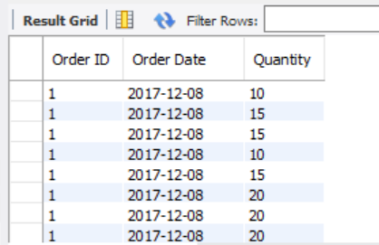
 | Explanation | Stored Procedure  Displays the Order ID, Order Date, and the Quantity of the item ordered of the given IN argument of an OrderID
 | SQL | -- Phase 3 Marie Kelling  -- 11. Create a Stored Procedure (not function) - takes in at least 1 IN ARGUMENT & returns at least 1 OUT ARGUMENT  USE brendasmek;  DROP PROCEDURE IF EXISTS OrdersDateQuantity;  DELIMITER $$  CREATE PROCEDURE OrdersDateQuantity (OrderID INT)  BEGIN  SELECT  Orders.ID AS 'Order ID',  Orders.OrderDate AS 'Order Date',  Quantity  FROM  Orders  INNER JOIN  OrderLineItem  WHERE Orders.ID = OrderID  ORDER BY Orders.OrderDate;  END $$  DELIMITER ;  CALL OrdersDateQuantity(2);
 | Result Grid | 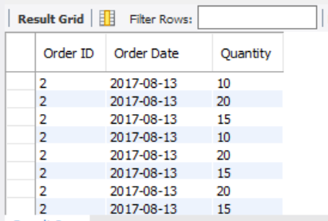
 | Result Grid | INSERT Trigger
 | SQL | -- Phase 3 Marie Kelling  -- 12. BEFORE INSERT that prepares data to make sure it complies to rules  USE brendasmek;  DROP TRIGGER IF EXISTS Employee_Before_Insert ;  DELIMITER $$  CREATE TRIGGER Employee_Before_Insert  BEFORE INSERT ON Employee  FOR EACH ROW  BEGIN  SET NEW.Email = CONCAT(NEW.FirstName, NEW.LastName, '@BrendasBakery.com');  END $$  DELIMITER ;  INSERT INTO Employee (ID, FirstName, LastName, Street, City, State, ZipCode, Country, Phone, BirthDate, SSN, Email)  VALUES (31, 'Bob', 'Cork', '384', 'Cleveland', 'OH', '44056', 'United States', '330-308-5620', '2017-05-05', '341479910', 'bcork0@irs.gov');  SELECT * FROM Employee;
 | Explanation | This Trigger checks each newly inserted Employee record and changes the Email field into the correct format
 | Result Grid | UPDATE Trigger
 | SQL | -- Phase 3 Marie Kelling  -- 13. BEFORE UPDATE that tests data quality and throws an error when bad data comes in  USE brendasmek;  DROP TRIGGER IF EXISTS OrderDate_Before_Update;  DELIMITER $$  CREATE TRIGGER OrderDate_Before_Update  BEFORE UPDATE ON Orders  FOR EACH ROW  BEGIN  IF NEW.OrderDate > CURDATE()  THEN  SIGNAL SQLSTATE VALUE '45000'  SET MESSAGE_TEXT= 'Oder date may not be in the future';  END IF;  END $$  DELIMITER ;  UPDATE Orders  SET OrderDate = DATE(NOW())  WHERE ID = 1;  UPDATE Orders  SET OrderDate = DATE_ADD(NOW(), INTERVAL 1 DAY)  WHERE ID = 1;
 | Explanation | This Trigger throws an error if the date of an Order placed is recorded in the future by mistake
 | Result Grid | DELETE Trigger  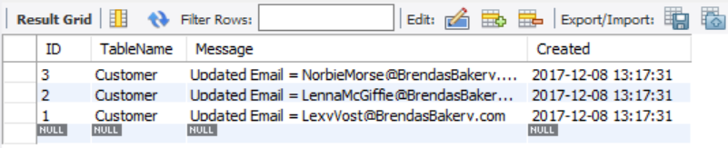
 | SQL | -- Phase 3 Marie Kelling  -- 14. AFTER DELETE that writes a record into a log/audit table  DROP TABLE IF EXISTS CustomerLog ;  CREATE TABLE IF NOT EXISTS CustomerLog  (  ID INT NOT NULL AUTO_INCREMENT,  TableName VARCHAR(255) NOT NULL COMMENT 'The table that is being logged',  Message VARCHAR(255) NOT NULL COMMENT 'The logging message',  Created DATETIME NOT NULL DEFAULT NOW(),  PRIMARY KEY (ID)  )  ENGINE = InnoDB  COMMENT 'The system log table' ;  CREATE UNIQUE INDEX CustomerLog_UNIQUE ON CustomerLog (ID ASC) ;  -- --------------------------------------------------------------------------------------  USE brendasmek;  DROP TRIGGER IF EXISTS Customer_After_Update;  DELIMITER $$  CREATE TRIGGER Customer_After_Update  AFTER UPDATE ON Customer  FOR EACH ROW  BEGIN  INSERT INTO CustomerLog (TableName, Message, Created)  VALUES ('Customer', CONCAT('Updated Email = ', New.Email), NOW());  END $$  DELIMITER ;  UPDATE Customer  SET Email = 'LexyVost@BrendasBakery.com'  WHERE ID = 5;  UPDATE Customer  SET Email = 'LennaMcGiffie@BrendasBakery.com'  WHERE ID = 6;  UPDATE Customer  SET Email = 'NorbieMorse@BrendasBakery.com'  WHERE ID = 7;  SELECT * FROM CustomerLog  ORDER BY ID DESC;
 | Explanation | This Trigger adds all of the updated Customer Emails into a log table called ‘CustomerLog’
 | Summary | What is the most important thing you personally learned in this project?  I learned a lot from this project, but the most important thing would be just simply learning the ins and outs of Database design because I had no prior experience in this area.  If you had to do this over again, what would you do differently?  I would start earlier and practice the queries more in order to complete the project more quickly and efficiently

